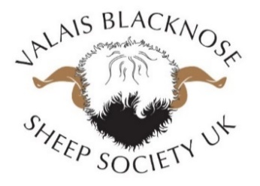
CASTRATE OR NOT CASTRATE
We would advise castrating any ram lamb who does not comply with the breed standard.
We want to breed the best we can in this country and also stay true to the Swiss breeding standard so making sure the rams used are correctly marked and shaped is paramount.
For more information on castrating please go to :-
http://adlib.everysite.co.uk/adlib/defra/content.aspx…

