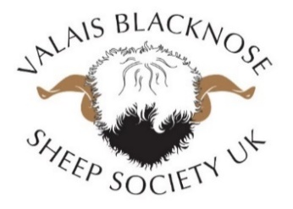

MV Accreditation
MV update 🐑
The MVAS/CAEAS is a voluntary scheme which allows you to demonstrate that your animals have been tested and are accredited free of MV/CAE.
What is Maedi Visna/Caprine Arthritis Encephalitis?
Maedi Visna (MV) is a chronic infectious viral disease affecting the lungs and nervous system of sheep which can be transmitted between individual sheep and flocks. The virus which causes Caprine Arthritis Encephalitis (CAE) in goats is very similar to MV virus and there is evidence that cross infection can occur between species. Therefore for the scheme purposes “animal(s)” refers to both sheep and goats.
Blood testing allows identification of infection. There is no vaccine or cure.

