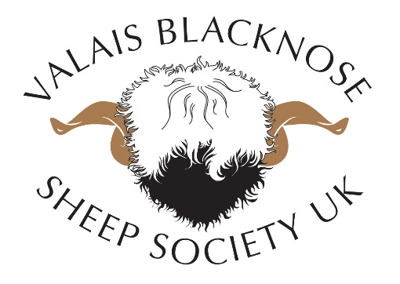
VBSSUK AGM Minutes
Location: Borderway Mart, Rosehill, Carlisle, CA1 2RS
Date: Friday 24th August 2018
Time: 18:15
Chairperson: Jamie Wood

Present: Henry Duncan, Jemma Knowles brown, Emily Duncan, Andrew Knowles Brown, Jo Jacobsen, Symon Jacobsen, Andrew Polson, Andrew & Elaine Boyle, Shannon Polson, Kirsty Stewart, Alex Burch, Bruce Goldie, Heather Adams, Kerry Jones, Dai Roberts, Jamie Wood, Raymond Irvine, Jennifer McAllister, Kathy Barker.

Agenda

1. ​Apologies
2.​ Minutes of the previous AGM
3.​ Matters arising from the previous minutes
4.​ Correspondence
5.​ Chairman's Report
6.​ Treasurers Report
7.​ Committee Appointments & Elections
8. AoB

(JW) Thanks for attending the first AGM. This is the first time that we’ve been able to come together to be able to form a committee. The main reason is to be able to form a committee to operate VBSSUK. Andrew Knowles brown will on behalf of VBSSUK chair the meeting.
(AKB) The agenda is very standard as this is our first meeting. VBSSUK was formed by directors in 2014. Chairperson report has been prepared.

- Apologies:
No apologies to communicate to those present
- Minutes of the previous AGM
There are no minutes from previous as this is the first AGM.

- Matters arising from the previous minutes
There are no matters arising from previous minutes as this is the first AGM.

- Correspondence
No correspondence received.

- Chairman’s Report

I would like to welcome you all to our first VBSSUK AGM since the society formed in 2014.
The society was formed by Jenni McAllister, Raymond Irvine and myself - Jamie Wood.
When Jennie, Raymond and myself first discussed forming the society our main goal was to keep the breed going forward whilst maintaining Swiss standards. Making sure that we stuck to Swiss breeding rules and standards to make sure the breed keeps going in the right direction and that breeders and owners understand how to do this.
So 2016 saw the first Blacknose Beauties show, inviting Swiss judges over to examine and grade all sheep in exactly the same way as has been done for many generations in Switzerland.
A credit to everyone that the judges in the past two years have been overwhelmed at how the sheep look and also appreciating how much work had already been given to producing well presented sheep in such a short period of time.
Personally I think this goes down to the ways of British farmers always striving to put 100% into welfare and presentation of their animals.

Jenni, Raymond and I would like to say a special thank you to a few of our members who have come forward to help organise and run the show over the last two years.
Thanks go to -
Emily Duncan
Jemma Knowles-Brown and
Andrew Knowles-Brown
It is much appreciated by all of us.

The society has gone from strength to strength over the years. In the first year gaining 28 members to the 55 members we have to date.
We now have sheep all over the country so forming a structural society is the next step in maintaining the breeding of the Valais Blacknose and also to protect its genetic value which is equally important.

Chairperson report was read by Andrew Knowles Brown.

- Treasurer Report
To be supplied by Jamie Wood and entered in Appendix.

- Committee & Elections

Committee members that are due to stand down in rotation after the completion of their term in office are eligible to stand for re-election. If any fully paid up member wishes to stand for election or nominate another, please apply to info@valaisblacknosesheepsociety.co.uk before end of day Monday 20th August 2018.

The office positions are as follows:
- Chairperson
- Vice Chairman
- Secretary
- Treasurer
- Social Media & Advertising
- Committee Members x 2
The Officers will be voted on an annual basis at the first committee meeting after an AGM.

(AKB) It has been decided that a committee of 7 will be formed. There have been 5 opted nominations:
Jamie Wood
Raymond Irvine
Jenni McAllister
Elaine Boyle
Jemma Knowles Brown
If you want to nominate yourself for the committee then notify Jenni.

(AKB) Unanimous vote for the above to go forward.

8. AOB
(Q) How frequent and where will committee meetings be held?
(A) Meetings will be carried out via conference call.

(Q) How long will a committee member stand for?
(A) For the first year, it will be decided who will stand for 1, 2, 3 years so that members are not retired at the same time.

(Q) Do we know yet what roles are appointed?
(A) Roles will be appointed at the first meeting after this AGM.

