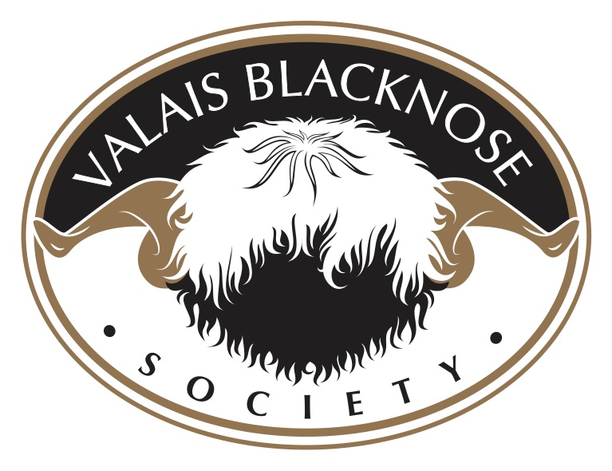

Hoof Care

The Healthy Hoof – Know what is ‘normal’
Knowing how a healthy foot should look will make it easier to recognise abnormalities and disease.

A normal foot has a hard wall of horn around two claws, each with a softer sole horn at the base. In healthy sheep, the interdigital skin between the claws is pale pink, dry, with a layer of fine hairs.

The sole horn is only 2-3mm thick and easily damaged by thorns or other sharp objects. The wall horn bears the sheep’s weight, so a normal foot has wall horn that extends beyond the sole.

In a healthy foot, the horn of both sole and wall is intact without smell, heat, softness or separated horn. If you’re Valais sheep is not lame and its feet are of normal shape leave well alone.

Wall horn grows at rate of about 5mm a month and the length of sheep feet varies naturally over the seasons. Over a year growth often matches wear so trimming is not necessary.

On some occasions the wall horn curls over the sole horn. This does not usually cause harm so foot trimming is unnecessary, unless the hoof horn is severely overgrown and the sheep is lame.

Common causes of foot problems:
Scald (interdigital dermatitis)
Foot rot
Shelly hoof
White line (toe) abscesses
Toe Granuloma (strawberry foot)
Valais Blacknose are quite prone to foot problems due to alot of wool between their toes we advise to hose feet out removing all debris, remove wool between hooves and spray with antibiotic spray most common one used is Terramycin spray (blue/purple spray) which you can buy from your veterinary practice.
