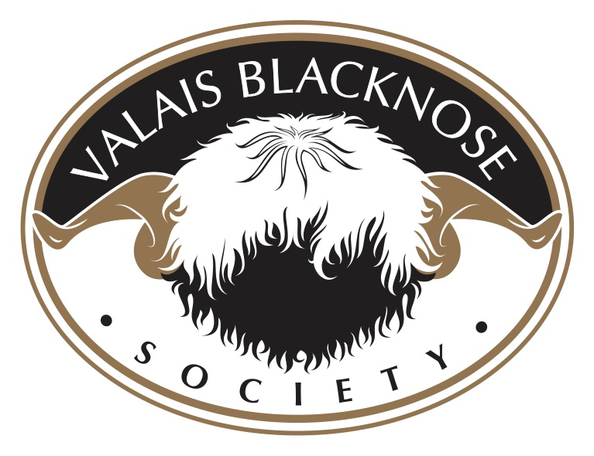

ORF
The cause is a pox virus which can remain infective in the environment for many months in dried scabs. Contagious pustular dermatitis virus (Also referred to as, CPD, Orf, Scabby Mouth, Contagious Ecthyma) most commonly results in proliferative lesions following trauma of the coronary band and lips/gums being particularly severe in artificially-reared lambs.
Outbreaks of CPD may occur within 10 to 14 days of pasture change especially onto those pastures which contain thistles, gorse. or stubbles which cause superficial trauma to the lips/mouth. Contagious pustular dermatitis is a zoonosis (can affect man) and precautions are necessary when handling suspected cases.
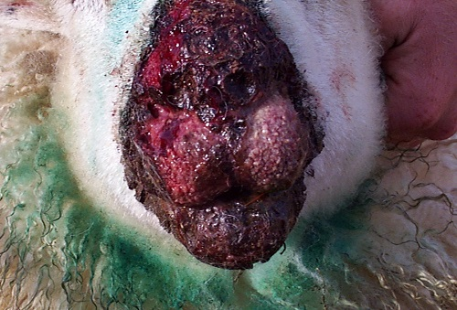

Fig 1: Contagious pustular dermatitis virus most commonly results in proliferative lesions following trauma of the lips/gums

Clinical presentation
Contagious pustular dermatitis virus most commonly results in proliferative lesions at the hoof/horn junction and on the lips/gums. The proportion of the flock affected can be high but mortality in uncomplicated cases is low. Lesions persist for four to eight weeks then slowly regress. Initial papule and vesicle stages are rarely observed. Scabs progressing to large proliferative wart-like structures, which bleed profusely following trauma to their base, are the more common presentation. Large scabs are often present at the commisure of the lips and along the gum margins surrounding the incisor teeth. Much less commonly, lesions may involve the hard palate and tongue.
In the UK, virus rapidly spreads within a group of orphan lambs sharing the same feeding equipment. In sucking lambs lesions frequently develop on the medial aspect of the ewe's teats; this area of the teat having been traumatised by the lamb's incisor teeth permits entry of virus. These teat lesions are painful and the ewe will typically not allow the lambs to suck. Mastitis, occasionally gangrenous in nature, may follow the development of CPD teat lesions.
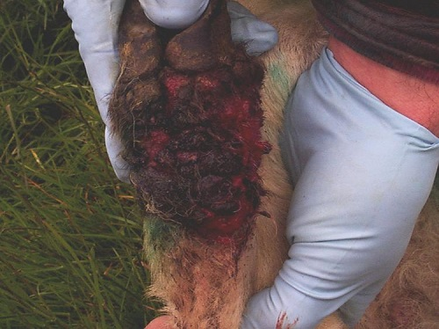

Fig 2: CPD virus and Dermatophilus congolensis may act together to produce large granulomatous masses extending 4 to 8 cms from the coronary band often referred to as "strawberry footrot".
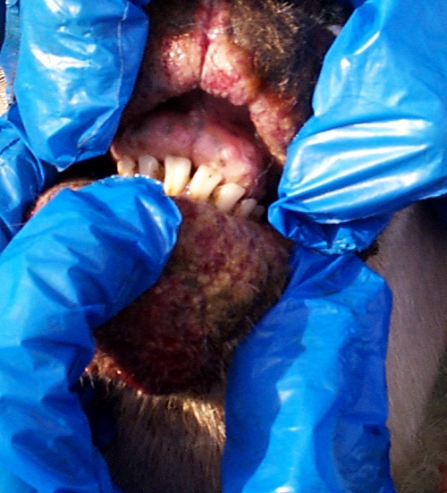

Fig 3: Contagious pustular dermatitis is a zoonosis (can affect man) and precautions are necessary when handling suspected cases
Contagious pustular dermatitis virus and various bacteria, including Staphylococcus aureus, may act together to cause severe facial dermatitis which appears as sharply-demarcated areas on the muzzle and involving the lower lip with scab material also palpable within the hairs extending for a further 2-3 cms from the periphery of the visible lesions. The skin is oedematous with serous exudation and superficial pus accumulation and other foreign material which may become desiccated forming hard scabs separated by deep fissures. Careful removal of the scabs reveals a deep bed of exuberant granulation tissue.
Contagious pustular dermatitis virus and Dermatophilus congolensis may act together to produce large granulomatous masses extending 4 to 8 cms from the coronary band often referred to as "strawberry footrot". These lesions bleed profusely when traumatised. Typically, strawberry footrot lesions only affect one leg and are more commonly seen in weaned lambs recently moved onto stubbles. While lesions are severe in individual lambs, the proportion affected is generally low.
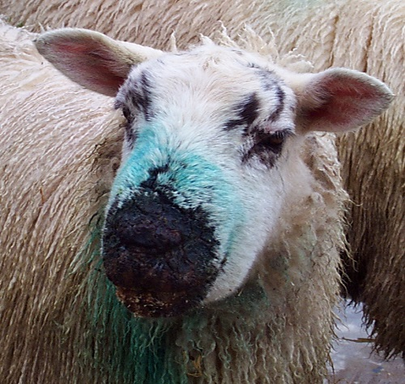

Fig 4: Contagious pustular dermatitis virus and various bacteria may act synergistically to cause severe facial dermatitis. (See Fig 5 for treatment response)
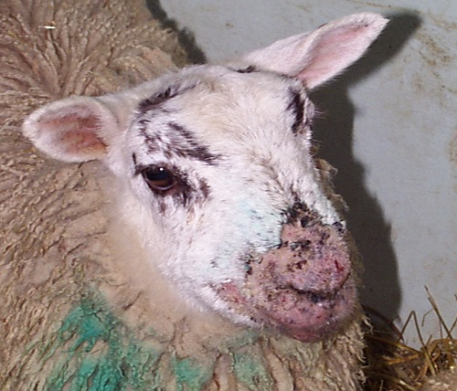

Fig 5: Secondary bacterial infection of scabs show a good response to either intramuscular procaine penicillin or oxytetracycline injections and topical oxytetracycline spray for three to five consecutive days (Same lamb as Fig 4)
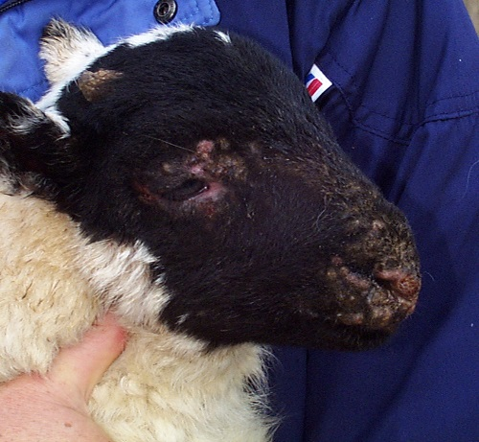

Fig 6: Veterinary examination is necessary because not all facial lesions are caused by CPD

Diagnosis
The diagnosis of CPD is based upon the finding of large proliferative lesions around the lips and nostrils of growing lambs. Virus can be demonstrated at veterinary laboratories by direct electron microscopy of fresh lesions.
Early lesions of CPD are readily distinguished from foot and mouth disease and Bluetongue but farmers must always consult their veterinary surgeon if they are in any doubt.

Treatment
Treatment is largely unsuccessful except for lambs with superficial secondary bacterial infection of scabs which show a good response to either intramuscular procaine penicillin or oxytetracycline injections and topical oxytetracycline spray for three to five consecutive days. Protective clothing and gloves must be worn when handling affected sheep because of the zoonotic risk.
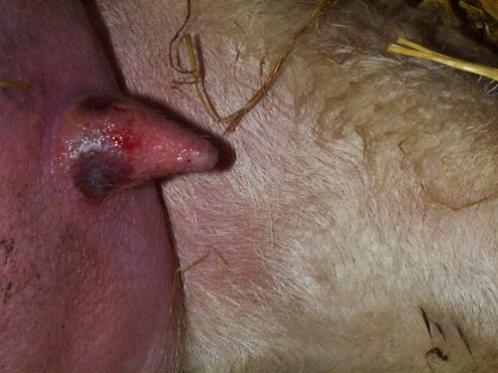

Fig 7: In sucking lambs lesions frequently develop on the medial aspect of the ewe's teats; this area of the teat having been traumatised by the lamb's incisor teeth permits entry of virus

Management/Prevention/Control measures
Disease is introduced into a flock by carrier sheep with no obvious skin lesions. Infection can remain viable in dry scab material in buildings for many months and is the likely reason for persistence of infection from year to year on the same premises. Thorough cleaning and disinfection of lambing accommodation may therefore help to break the usual annual appearance of disease.
Control following scarification with a live vaccine proves difficult to quantify but is routinely undertaken in many flocks in the UK. Vaccine must never be used in a flock with no history of CPD. Vaccination is by scarification of the inner thigh in lambs and the axillary region in ewes. The timing of vaccination is approximately 6 weeks before the anticipated occurrence of disease. Care must be exercised during handling the live vaccine as it is affected by high temperatures and inactivated by disinfectants.
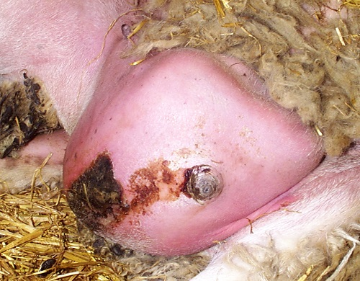

Fig 8: Gangrenous mastitis following CPD lesion on ewe's teat

Economics
Contagious pustular dermatitis is a significant problem in orphans lambs and other ill-thriven lambs, CPD is less of a problem in well-fed, well-thriven stock. The vaccine is inexpensive but the procedure is time-consuming and there is the risk of human infection.

