Sheep Scab

Sheep scab, caused by the mite Psoroptes ovis leads to major economic losses to the UK flock and impacts sheep welfare.
Sheep scab is spread by any contact with live mites. This is usually through direct sheep-to-sheep contact on commons, via break-ins, at markets or in livestock lorries. Adult mites can survive for up to 17 days in the environment enabling indirect spread via rubbing posts, trees, hedges and fences. Shearing combs and cutters, contaminated clothing, tags of wool or scabs can also harbour and spread mites. In rare cases, scab can infect cattle.
Clinical Signs
The adult mites live in the skin surface where their faeces cause an intense allergic reaction. Females lay eggs which hatch and develop into adults over 10-14 days. They prefer moist areas and cause clinical cases most commonly on fully fleeced animals between September and April. Summer cases are seen usually on fully fleeced or poorly shorn animals. Shorn sheep can carry live mites in the skin folds around the tail head and legs without showing any symptoms. Animals are often seen at different stages of the disease within affected flocks.
During the early stages of sheep scab, infestations are not obvious, and animals often appear clinically normal. It can take 40-50 days after infection before signs are seen. There are low mite numbers and very small, virtually undetectable lesions. The first visible signs can be restlessness, rubbing against fence posts, soiled and stained areas of wool, head tossing and loose tags of fleece. Frequent rubbing against fences and wool tags on the wire may indicate sheep scab or louse infestation.
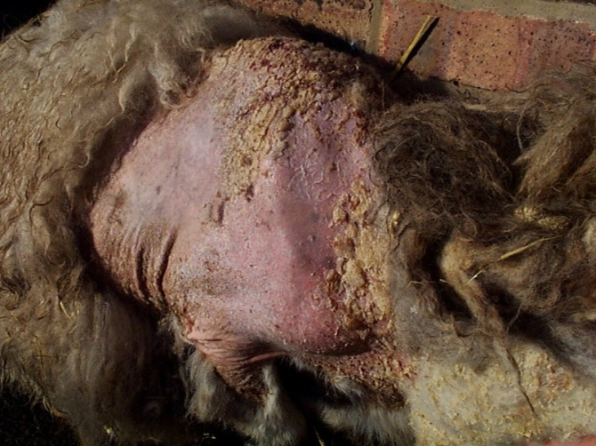
The distraction caused by intense itching reduces feeding and there can be a rapid and significant loss in body condition. The loss of fleece and poor nutrition can lead to death through pneumonia or hypothermia. In serious cases, animals will start fitting, particularly when moved.
Diagnosis
Farmers must seek veterinary advice to get a correct diagnosis. To confirm sheep scab, skin scrapes from the edge of a crusting lesion can be examined under a microscope to identify the mite. This test confirms a current infestation and all sheep in the affected group must be treated. Samples of fleece only or skin scrapes from the centre of a lesion from an infected sheep may not contain mites. Examination of the skin by eye is insufficient. It can confirm a louse infestation but does not rule out the presence of scab mites and both can be present on the same animal. In addition to microscopy, sheep can be blood tested for antibodies to sheep scab. The test will not return a positive result for at least two weeks after infection. It is only suitable to test purchased or returning animals which have been isolated for two weeks prior to sampling. Positive results confirm recent exposure to scab mites but the results will remain positive for several months even after effective treatment.
Your veterinary practice shall advice you on the best treatment available. Sheep dipping yearly reduces the risk of Sheep Scab.
For more information please go to https://nadis.org.uk/disease-a-z/sheep/sheep-scab/

