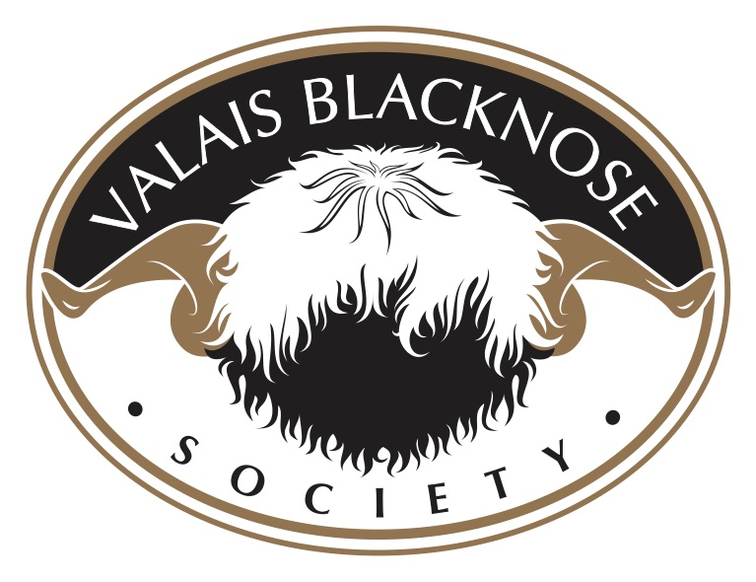

The ‘Spitti’
Occasionally a purebred Valais Blacknose may produce offspring marked in reverse colour /markings which are referred to as ‘Spitti’, a name adopted here in the UK from Swiss Blacknose breeders. The appearance of a Spitti can vary, some have predominantly black wool instead of white, others may feature a splotching pattern.

Points to note:
- A sheep featuring common mismarks i.e. extra leg spots or a single large colour spot is not a Spitti.
- A Spitti is an offspring from purebred parentage (both dam and sire). Offspring born from crossbreeding i.e. Valais Blacknose and Jacob sheep do not classify as Spittis.
- Spitti females are eligible for breeding and Grassroots registration but require DNA parentage verification to ensure that they are pure bred.
- Spitti rams should be castrated and not used for breeding purposes.
- Spitti males can be ‘Listed’ with the Grassroots registry as non-breeding animals if required and will be issued with a pink ‘Listed - Non-Breeding’ certificate.

Photo credit:
Jamie Wood @valaisblacknosesheepnorthumberland

