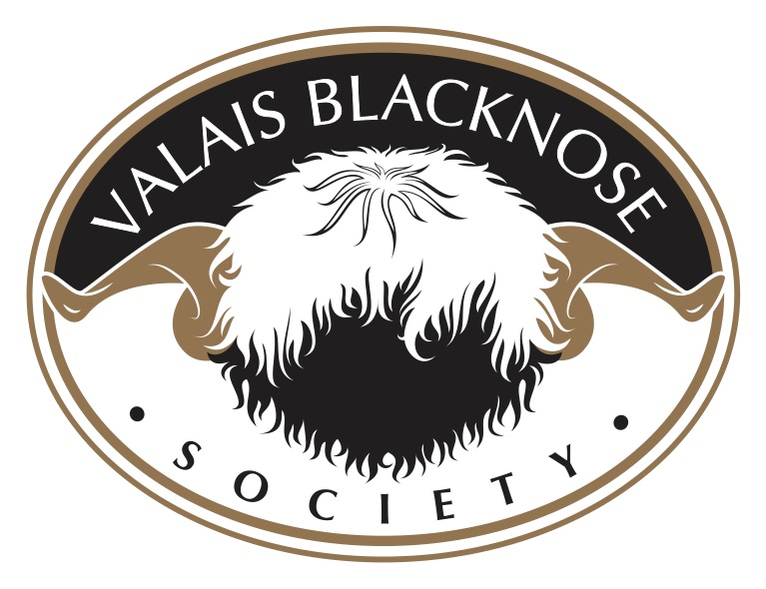

WATERY MOUTH DISEASE

✨"PREVENTION IS BETTER THAN CURE"✨

Watery mouth disease is a colloquial term (others include rattle belly) used to describe a collection of clinical signs in newborn lambs which includes lethargy, failure to suck, profuse salivation, bloating and retained meconium. The condition is caused by colonisation of the small intestine by E. coli with rapid multiplication and release of toxins.
Initial infection results from a high environmental bacterial challenge from dirty, wet conditions in the lambing shed and pens, and from ewes with faecal staining of the wool of the tail and back end. Colonisation of the gut and rapid bacterial growth is facilitated by inadequate or delayed colostrum intake. These risks are higher in lambs of low birthweight, from ewes in poor condition or ill health, in multiples, following difficult births and due to mismothering.
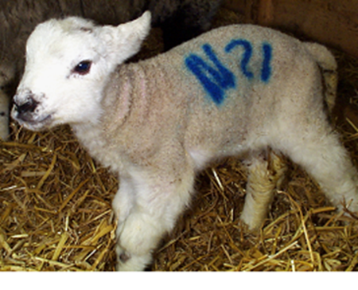
Figure 1. Lambs with watery mouth are initially dull, lethargic, depressed and reluctant to suck.

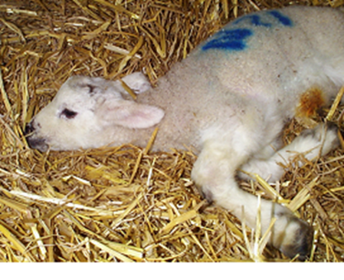
Figure 2. Watery mouth disease can quickly progress to coma and death.

Watery mouth disease is commonly encountered in twins and especially triplet lambs aged 12 to 36 hours kept in unhygienic conditions. Affected lambs are dull, lethargic, depressed and reluctant to suck. They frequently lie in the corner of the pen and rarely stretch or show interest in sucking when encouraged to stand. Within 2 to 6 hours there is profuse salivation, a wet lower jaw and increasing abdominal distension, despite the lamb not feeding. The condition can quickly progress to coma and death.
Watery mouth can be diagnosed based on the clinical signs in the live lamb. If there are high levels of mortality, fresh lamb carcasses should be submitted for post mortem examination to confirm the diagnosis. Blood samples from live lambs less than one week of age can also be tested easily to see if colostrum intake was adequate and help identify risk factors which may be contributing to an outbreak.

Treatment
Despite bloating, lambs with watery mouth disease need oral electrolyte therapy at a rate of 50 mls per kg four times daily to prevent dehydration. During the early stages soapy water enemas such as diluted washing-up liquid, or other laxatives may be used to promote gut activity and expulsion of meconium. Oral antibiotics may be effective during the early phase of the disease but veterinary advice should be sought to ensure treatment protocols are appropriate.

Prevention and Control
Problems with watery mouth disease are often worse in housed flocks towards the end of the lambing period as the bacterial challenge builds up. All attempts must be made to improve hygiene standards in the lambing shed. Wherever possible, the remaining pregnant ewes should be moved to another building, or weather permitting, turned out to pasture. It is important to ensure lambs receive enough good quality colostrum to ensure adequate immunity.

Control measures must include:
- Correct nutrition of pregnant ewes (to ensure correct birth weights and good quality colostrum).
- Abundant clean, dry straw bedding.
- Cleaning and disinfection of individual pens between lambing ewes.
- Collection and disposal of afterbirths.
- Ensure that lambs suck colostrum within two hours of birth or are supplemented by bottle or stomach tube.
- Ensure lambs receive 50mls per kg of quality colostrum in the first two hours and 200mls per kg in the first 24 hours.
Routine antibiotic administration to prevent watery mouth disease in lambs is not justified. The industry has targeted stopping antibiotic use for this purpose as part of its commitment to tackle antibiotic resistance. All efforts to prevent the disease should be made and veterinary advice sought if disease outbreaks occur.

