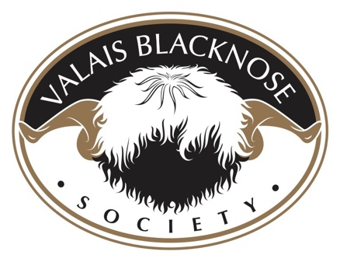

CASTRATE OR NOT CASTRATE

We would advise castrating any ram lamb who does not comply with the breed standard. Pedigree breeding rams should be selected and registered based on 3 grading areas in line with the Swiss breeding standards: Markings, Conformation and Fleece. A good stock ram should meet the criteria within each grading area and be evaluated as an entire animal. The breed standards can be found here: https://valaisblacknosesociety.co.uk/the-breed/

For more information on castrating please go to:-
Castration and tail docking

