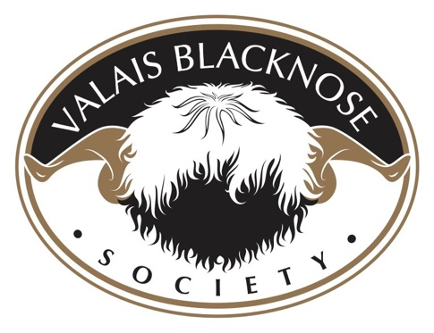

Preparing your Valais Blacknose Fleece for Sale

Please see below some tips on how to keep your Valais Blacknose fleeces in tip top condition in preparation for selling.

- Regular crutching around the bum and belly area to minimise faeces and felting on the main fleece. Every 2-3 months ideally.
- Valais sheep need to be sheared twice a year. Lambs are sheared in September of the year they were born. Then again in March so that they grow enough length for showing. This is a guide, if you have particular shows you wish to attend then shear accordingly. However, shearing every 6 months is vital to ensure healthy sheep.
- Ideally to maintain a gorgeous white fleece – washing is essential. Some breeders use warm water in large tubs/baths in conjunction with products such as non-bio detergent. These products help break down any dirt of lanolin which has built up in the fleece. Tease the locks with fingers or a wide tooth comb while the fleece is wet – never brush the fleece once dry. Washing the sheep prior to shows and shearing will help present the sheep well in the ring and also add value to the fleece when you come to sell it.
- To help keep the job a lot easier, you need to think about what the sheep have access to while grazing. Brambles, thorns, gorse and hay are the worst vegetation matter to be picking out of fleeces – and your purchasers do not want to be left with a fleece they’ve paid good money for to have to then throw it away. The time it would take to pick all the bits out would be impossible. Keep hedgerows cut back or fenced so that the sheep cannot reach into them. Keeping them well away from gorse bushes as the needles are very sharp.
- When housing the flock, keep all hay feeders below head level – this stops them from pulling it all over their back and top of the head. Also, on to other sheep beside them. Again, if housed over winter, ideally you would need to wash them 2-3 days before shearing.
- If there are not many Valais in a breeder’s flock or if keeping them as pets, they don’t’ really need to be marked like a commercial sheep. This de-values the wool hugely as it does not wash out. If you do need to mark your sheep, best way if you’re planning to sell your fleece for a premium price, is to mark the sheep on the back of their head – not on their back.
- Shearing Valais Blacknose sheep are a little different to shearing commercial sheep and extra care is required to ensure a clean job and whole fleece collected intact. You need to be able to collect the fleece in a clean and tidy environment, rush of the job will lead to fleeces getting dirty. Make sure the shearer has a clean area / board to work on. Brush the shearing space between each sheep. Pull away any dirty wool when the shearer is cutting around the rear end and edges of the main fleece, so it doesn’t contaminate the clean fleece. Remember to remove all the black wool out of the fleece and any fine black hair. It is unusable.
- Prepping of the fleece is the final task. Once you have taken the fleece away from the shearing board, lay it out either on a table or a clean sheet away from any hay or straw lying around. (Remember clean environment minimises vegetation matter getting on to the fleece). Pick off any dirty wool from the edges including any black wool that may have fallen on to the white wool. Any dirt/hay/straw is to be picked off. Do not wrap the belly wool or any of the wool that has been discard during the shearing. This dirty wool needs to be bagged and binned. This leaves you with beautifully picked over fleece ready to be rolled and bagged up to be sold.

Happy Sheep! Happy Wool!

