Burwarton Show 3rd August 2023
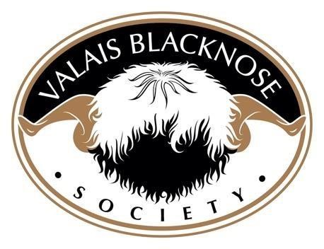
 | 1ST | 2ND |  | 3RD |  | 4TH |  | 5TH |  | 6TH
RAM | Cannon Hall  Sprout  Owned by – Hayley & Phil  Garrod  Bred by – Cannon Hall Farm |  | Fairview  Valleys  Jackpot  Owned & Bred by -Nina Price |  | Asbatch  Gethin  Owned & Bred by - Robert  Watkins |  | Orchard  Icarus  Owned & Bred by - Gordon  Preece
RAM LAMB | Puddle Lane  Kensington  Owned & Bred by – Hayley & Phil  Garrod |  | Wildheart  King  Owned by Karen McQuattie Bred by - Rodney  Wildman |  | Preen Vale  Krackerjack  Owned & Bred by - Penny  Hayward |  | New House  Kaleb  Owned & Bred by - Rebecca  Skellern |  | Felin Newydd’s  Kissimee  Owned & Bred by - Margaret  Bennett |  | Felin Newydd’s  Kaleb  Owned & Bred by - Margaret  Bennett
EWE | Puddle Lane  Isabell  Owned & Bred by – Hayley & Phil Garrod |  | Fairview  Valleys  Jubilee  Owned & Bred by -Nina Price |  | Puddle Lane  Ivy  Owned & Bred by – Hayley & Phil  Garrod |  | Wildheart  Jina  Owned by Karen McQuattie Bred by - Rodney  Wildman |  | Cheshire  Jacobella  Owned by - Sarah  Watson  Bred by – Steven Dace |  | Cheshire  Jesteena  Owned by – Sarah Watson  Bred by – Steven Dace

EWE LAMB | Maybrook  Klementine  Owned & Bred by – Howard & Sarah Tinkler | Puddle  Lane  Kappucinio  Owned & Bred by – Hayley & Phil Garrod | Puddle Lane  Kroissant  Owned & Bred by – Hayley & Phil  Garrod |  | Rose Villa  Kurly  Cookie  Owned & Bred by - Helen Smith |  | Abi Gatenby | Abi Gatenby
WETHER | Maybrook Kylian  Owned & Bred by – Howard & Sarah Tinkler | Asbatch  Socks  Owned & Bred by - Robert  Watkins
GROUP OF 3 | Puddle  Lane  Owned by - Phil &  Hayley  Garrod | Fairview  Valley  Owned by - Nina Price | Preen Vale  Owned by - Penny  Hayward |  | Felin Newydd’s  Owned by -  Margaret Bennett |  | Asbatch  Owned by - Vanessa  Watkins | Orchard  Owned by - Gordon &  Carol  Preece
CHAMPION |  | Puddle Lane  Kensington  Owned & Bred by – Hayley & Phil Garrod |  | RESERVE CHAMPION |  | Maybrook  Klementine  Owned & Bred by – Howard & Sarah Tinkler

