Dorset County Show 2nd & 3rd September 2023
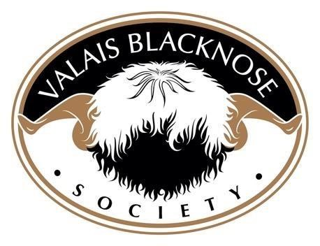
 | 1ST | 2ND | 3RD |  | 4TH | 5TH | 6TH
AGED RAM  or  SHEARLING  RAM | Iceni  Henry  Owned by - Carla  McLeod-  Bunter  Bred by – Georgina Hollis | Eiger  Jasper  Owned & Bred by - Barrie Haigh |  | Eiger  Idris  Owned & Bred by - Barrie Haigh | Halsbury  Jaguar  Owned by - Louise  Hebditch  Bred by – Chris Slee & Tom Hooper
RAM LAMB | Lacock  Kingstone  Owned & Bred by - Peter Self | Lambrook  Kermit  Owned & Bred by -Carla  McLeod-  Bunter |  | Skaigh  Krakatoa  Owned & Bred by – Douglas & Kate Little | Gander Cross  Knot So  Simon  Owned & Bred by - Emma Childs | Hewishstock  Kernal  Owned & Bred by – Olivia Barnes & Julie Beeson
AGED EWE  &  SHEARLING  EWE | Whitehall  Juniper  Owned by - Peter Self  Bred by – Henry & Emily Duncan | Skaigh  Jungfrau  Owned & Bred by – Douglas & Kate Little |  | Kentmere  Imogen  Owned by – Chloe Lukins  Bred by – Katy Fawcett | Eiger  Jade  Owned & Bred by - Barrie Haigh | Halsbury  Inky  Owned by - Carol  Retallick  Bred by – Chris Slee & Tom Hooper

EWE LAMB | Gander Cross  Kracken  Daze  Owned & Bred by - Emma Childs | Lacock  Kierra  Owned & Bred by – Peter Self | Goldies  Kira  Owned by - Carol Retallick  Bred by – Thomas & Isla Goldie | Lacock  Kitty  Owned by - Carla  McLeod-  Bunter  Bred by – Peter Self | Gander  Cross  Killer Queen  Owned & Bred by - Emma Childs
WETHER | Skaigh  Johannesberg  Owned & Bred by – Douglas & Kate Little | Lacock  Kai  Owned & Bred by – Peter Self | Eiger  Kegan  Owned & Bred by - Barrie Haigh | Hewishstock  Kermit  Owned & Bred by – Olivia Barnes & Julie Beeson | Hewishstock  Khan  Owned & Bred by – Olivia Barnes & Julie Beeson
PAIR OF EWE LAMBS |  |  | Hewishstock  Karena & Kez  Owned & Bred by – Olivia Barnes & Julie Beeson

GROUP OF 3 | Skaigh Sheep  Owned by – Douglas & Kate Little | Gander Cross Owned by - Emma Childs |  | Eiger  Owned by - Barrie Haigh | Lacock Owned by – Peter Self
LONGWOOL  WOOL ON  THE HOOF | Kentmere  Imogen  Owned by – Chloe Lukins  Bred by – Katy Fawcett
MALE CHAMPION | Lacock  Kingstone  Owned & bred by – Peter Self |  | FEMALE CHAMPION | Kracken  Daze  Owned & Bred by - Emma Childs
OVERALL BREED CHAMPION |  |  | Kracken  Daze  Owned & Bred by - Emma Childs
RESERVE BREED CHAMPION |  |  | Lacock  Kingstone  Owned & Bred by - Peter Self

