Doune & Dunblane Show 1st July 2023
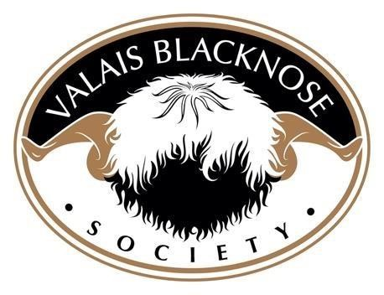

 | 1ST | 2ND | 3RD | 4TH | 5TH | 6TH
RAM (1 year and older) | Hardens  Ironman  Owned & Bred by - Rikki & Lauren McLean | Whiterigg  Jubilee Royale  Owned & Bred by - Katrina & Robbie Taylor | Glenchamber  Jaffa  Owned by -Alistair & Craig Scott  Bred by – Zoe McMillan | Prendwick  Invictus  Owned by - Katrina & Robbie Taylor  Bred by – Jamie Wood | PuddleLane  In A Pickle  Owned by – Ian & Michelle Cloggie  Bred by – Phil & Hayley Garrod | Moorland  Indiana  Owned by – Ian & Michelle Cloggie  Bred by – Helen Templeton-Smith
EWE (having suckled a lamb this season) | Jumble  Irma  Owned by - Katrina & Robbie Taylor  Bred by – William Hawtin | Balnuith  Ida  Owned & Bred by - Alison Wiseman | Balnuith  Irene  Owned & Bred by - Alison Wiseman
EWE (1 year old) | Hardens  Jasmin  Owned & Bred by - Rikki & Lauren McLean | Hardens  Jessica  Owned & Bred by - Rikki & Lauren McLean | Rosehall  Juniper  Owned by - Katrina & Robbie Taylor  Bred by – Mhairi Hosking & Graeme Wight | Westmorland Jezabel  Owned by - Cat Losty  Bred by – Tim Dunne & Susan Mullen | Daffodil Hill  Jubilee  Owned by - Alison Wiseman  Bred by – Jim Campbell | Westmorland  Jacquelina  Owned by - Cat Losty  Bred by – Tim Dunne & Susan Mullen
RAM LAMB | Whiterigg  Kaiser  Owned & Bred by - Katrina & Robbie Taylor | Whiterigg  Knight  Owned & Bred by - Katrina & Robbie Taylor | Kildimmery  Krug  Owned & Bred by - Ros Stewart | Balnuith  Kerry Oot  Owned & Bred by - Alison Wiseman
EWE LAMB | Whiterigg  Kiltie Cauld Bum  Owned & Bred by - Katrina & Robbie Taylor | Stormcloud  Kalli  Owned & Bred by – Ian & Michelle Cloggie | Whiterigg  Knotty Girl  Owned & Bred by - Katrina & Robbie Taylor | Stormcloud  Korra  Owned & Bred by – Ian & Michelle Cloggie | Kildimmery  Kurveball  Owned & Bred by - Ros Stewart | Kildimmery  Krystal  Owned & Bred by - Ros Stewart
GROUP OF THREE |  |  | Whiterigg  Owned & Bred by - Katrina & Robbie Taylor
CHAMPION |  | Hardens  Ironman  Owned & Bred by - Rikki & Lauren McLean |  | RESERVE CHAMPION | Hardens  Jasmin  Owned & Bred by - Rikki & Lauren McLean

