Ellingham Show, Somerley 12th August 2023
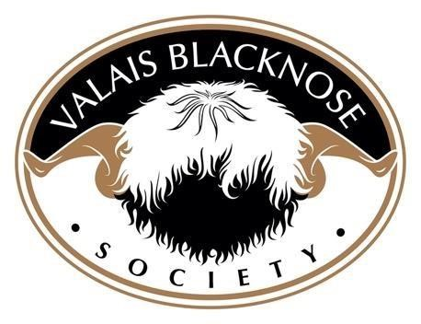
1ST |  | 2ND | 3RD |  | 4TH | 5TH | 6TH
AGED RAM | Five Acres  Boris  Owned by - Emma Childs  Bred by – Becky Wilcox | Forest Edge Horace  Owned & Bred by – Stuart & Polly Glyde |  | Yew Tree  Oscar  Owned by -Becky Wilcox  Bred by – Steven Dace | Gander  Cross  In Like Flynn  Owned by - Becky Wilcox  Bred by – Emma Childs
SHEARLING RAM | Dovecot  Janga  Owned & Bred by - Annie  Calais & Ruby Rogers | Cheshire  Jay I  Owned by – Emma Childs  Bred by – Steven Dace |  | Gander Cross  Jobs A  Good’n  Owned & Bred by -Emma Childs | Five Acres  Jay  Owned & Bred by - Becky  Wilcox | Hilda Leng  Jackpot Jo  Owned by – Emma Childs  Bred by – Philip Tindale
RAM LAMB | Forest Edge  Kingdom  Owned & Bred by – Stuart & Polly Glyde | Gander  Cross  Kinks N  Kurls Owned & Bred by -Emma Childs |  | Gander Cross  Knott so  Simon  Owned & Bred by -Emma Childs | Ganda Cross  Kanya  Swiss Owned & Bred by -Emma Childs | Gander  Cross  Krispy  Kreme  Owned & Bred by -Emma Childs | Five Acres Konker  Owned & Bred by - Becky  Wilcox

AGED EWE | Cheshire  Hearty Owned by – Emma Childs  Bred by – Steven Dace | Five Acres  Dotty  Owned & Bred by - Becky  Wilcox | Usk Valley  Hot Toddy  Owned by - Annie Calais & Ruby Rogers  Bred by – Miles & Lisa Morgan | Dovecot  Ice Maiden  Owned & Bred by - Annie  Calais & Ruby Rogers | Forest Edge  Gretl  Owned & Bred by – Stuart & Polly Glyde | Forest Edge  Imelda  Owned & Bred by – Stuart & Polly Glyde
SHEARLING  EWE | Forest Edge Judy  Owned & Bred by – Stuart & Polly Glyde | Hilda-Leng  Jitterbug  Joy  Owned by – Emma Childs  Bred by – Philip Tindale | Cheshire  Jean  Owned by – Emma Childs  Bred by – Steven Dace | Halsbury  Jamilia  Owned by - Vikki Evans  Bred by – Chris Slee & Tom Hooper | Gander  Cross  Just As Ewe  Are  Owned & Bred by -Emma Childs | Dovecot  Ivy  Owned & Bred by - Annie  Calais & Ruby Rogers
EWE LAMB | Gander Cross  Kings  Ginger  Owned & Bred by -Emma Childs | Gander Cross  Kraken  Daze  Owned & Bred by -Emma Childs |  | Gander Cross  Killer Queen  Owned & Bred by -Emma Childs | Dovecot  Kuti Pie  Owned & Bred by - Annie  Calais & Ruby Rogers | Gander  Cross  Keeper of  Secrets  Emma Childs
GROUP OF 3 | Gander  Cross  Owned by - Emma  Childs | Gander  Cross  Owned by – Emma Childs |  | Forest Edge Owned & Bred by – Stuart & Polly Glyde | Gander  Cross  Owned by - Emma  Childs

SUPREME CHAMPION | Forest Edge Judy  Owned & Bred by – Stuart & Polly Glyde |  |  | RESERVE CHAMPION | Cheshire  Hearty  Owned by – Emma Childs  Bred by – Steven Dace

