New Forest & Hampshire County Show 25th – 27th July 2023
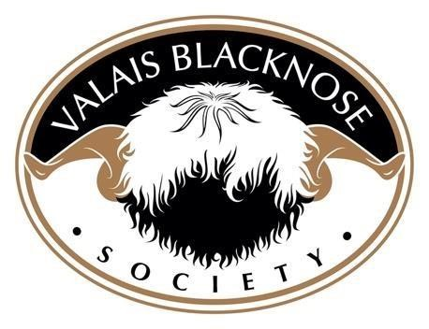
 | 1ST | 2ND | 3RD 4TH |  |  | 5TH | 6TH
EWE LAMB | Eiger Kitty  Owned by - Mr Gavin  Colborne  Bred by – Barrie Haigh | Firle Kiki Owned & Bred by – Tom Harvey & Isabel Barr |  | Gander Cross  Kraken Daze  Owned & Bred by - Emma  Childs | Gander Cross  Killer Queen  Owned & Bred by - Emma  Childs | Lacock  Katia  Owned & Bred by - Peter Self | Dovecot  Keepsake  Owned & Bred by - Annie  Calais & Ruby Rogers
SHEARLING EWE | Whitehall  Juniper  Owned by - Peter Self  Bred by – Henry & Emily Duncan | Forest Edge  Judy  Owned & Bred by – Stuart & Polly Glyde |  | Cheshire  Jean  Owned by - Emma  Childs  Bred by – Steven Dace | Eiger  Jade  Owned by - Mr Gavin  Colborne  Bred by – Barrie Haigh | Hilda-Leng  Jitterbug Joy  Owned by – Emma Childs  Bred by – Philip Tindale | Dovecot  Ivy  Owned & Bred by - Annie  Calais & Ruby Rogers
AGED EWE | Cheshire  Hearty  Owned by - Emma  Childs  Bred by – Steven Dace | Firle  Harmony  Owned & Bred by – Tom Harvey & Isabel Barr |  | Forest Edge  Imelda  Owned & Bred by – Stuart & Polly Glyde | Forest Edge  Gretl  Owned & Bred by – Stuart & Polly Glyde | Fernyford  Ingrid  Owned by- Emma Childs  Bred by – Neil Richardson & Dorota Falkowska | Five Acres Dotty  Owned & Bred by - Becky  Wilcox
RAM LAMB | Lacock  Kingston  Owned & Bred by - Peter Self | Gander Cross  Kinks & Kurls  Owned & Bred by - Emma  Childs |  | Gander Cross  Krispy Kreme  Owned & Bred by - Emma  Childs | Forest Edge  Kingdom  Owned & Bred by – Stuart & Polly Glyde | Firle  Kincaid  Owned & Bred by – Tom Harvey & Isabel Barr | Gander Cross  Kanya Swiss  Owned & Bred by - Emma  Childs
SHEARLING & AGED RAM | Lacock Jenson  Owned & Bred by - Peter Self | Five Acres  Boris  Owned by - Emma Childs  Bred by – Becky Wilcox |  | Forest Edge  Horace  Owned & Bred by – Stuart & Polly Glyde | Firle  Invincible  Owned & Bred by – Tom Harvey & Isabel Barr | Yew Tree  Oscar  Owned by - Becky Wilcox  Bred by – Steven Dace | Dovecot  Janga  Owned & Bred by - Annie  Calais & Ruby Rogers
GROUP OF THREE | Mrs Emma  Childs | Mrs Emma  Childs |  | Mr Gavin Colborne | Mrs Becky Wilcox | Mrs Polly Glyde | Mr Peter Self
WOOL ON  THE HOOF |  | Eiger Jackpot  Owned by - Mr Gavin  Colborne  Bred by – Barrie Haigh |  | Pixley Jett  Owned by -Emma  Childs  Bred by – Abi Gatenby |  |  | Forest Edge  Kingdom  Owned & Bred by – Stuart & Polly Glyde
MALE CHAMPION | Lacock Jenson  Owned & Bred by - Peter Self |  |  | FEMALE CHAMPION | Whitehall Juniper  Owned by - Peter Self  Bred by – Henry & Emily Duncan
SUPREME CHAMPION | Whitehall Juniper  Owned by - Peter Self  Bred by – Henry & Emily Duncan |  |  | RESERVE CHAMPION | Five AcresBoris  Owned by - Emma Childs  Bred by – Becky Wilcox

