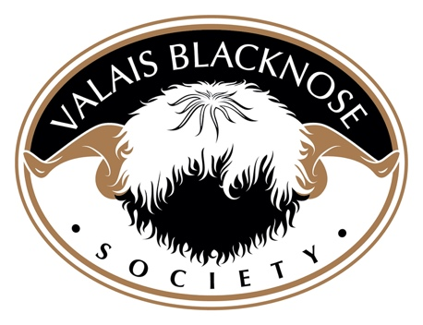
A + Panel Judges

Society Shows & Grading Events, Royal Shows 3 Days and Over.

David Hodge (Grader) Lower Halstock Farm, Okehampton, Devon, EX20 1QR
Tel: 01837 748023
Email: halstockshetlands@gmail.com

Raymond Irvine (Grader) Mains of Inverourie Farm, Tomintoul, Ballindalloch, Morayshire, AB37 9PH
Tel:
Email: raymondirvine@btinternet.com

Jenni McAllister (Grader) Mains of Inverourie Farm, Tomintoul, Ballindalloch,Morayshire, AB37 9PH
Tel:
Email: jmcallister@fastmail.fm

Chris Slee (Grader) 1 Halsbury Barton Cottages, Buckland Brewer,
Bideford, Devon, EX39 5EL
Tel : 07812 681094
Email: info@halsburybarton.co.uk

Jamie Wood (Grader) Prendwick Farm, Whittingham, Alnwick,
Northumberland, NE66 4UZ
Tel: 07832 145773
Email: jamiewood66@hotmail.co.uk

Phil Garrod (Grader) Corner House. Dilwyn, Hereford, HR4 8JL
Tel: 07974 577197
Email: ptg1979@icloud.com

A + Panel Judges - Continued

Society Shows & Grading Events, Royal Shows 3 Days and Over.

Julian Walters (Grader) Lower Halstock Farm, Okehampton, Devon,
EX20 1QR
Tel : 01837 748023
Email: halstockshetlands@gmail.com

Heather Adams (Grader) Taddington, Buxton, Derbyshire
Email: deepdale.valais@gmail.com

Gerallt Jones (Grader) Pant Gwyn, Waunfawr, Caernarfon, Gwynedd, LL55 4DX
Tel: 07717 281485
Email: gerallt.alfie@gmail.com

A Panel Judges

Regional Club Shows, Royal and county shows 3 days and under.

Bruce Goldie Townfoot Farm, Mouswald, Dumfries, DG1 4LX
Tel: 07712 435 408
Email: bruce@goldietownfoot.co.uk

B Panel Judges

Local and Agricultural Shows.

Emma Glacken 3 Humbie Holdings, Kirknewton, West Lothian, EH27 8DS
Tel: 07739 961847
Email: Hattonsheep@hotmail.com

Irene Gray 31 Alexandra Park, Muckamore, Antrim, NI BT41 4RD
Tel: 07815 091866 Landline 02894 429413
Email: Irenebrown_2000@yahoo.co.uk

Steve Dace Valais Farm, Birtles Lane, Over Alderley, Cheshire, SK10 4RY
Tel: 07973 262871
Email: steve@cheshirepoultry.co.uk

Susan Mullen Birks Farmhouse, Bleatarn, Appleby, Cumbria, CA16 6PZ.
Tel: 07961 904 368
Email: suemullen@live.co.uk

Emma Collison Gemstones, Ninestones Farm, Liskeard, PL14 6SD
Tel: 07803 003960
Email: info@moorviewalpacas.com

