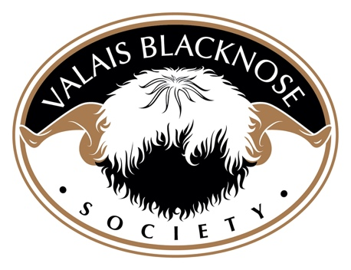
29 March 2024

Dear Valais Blacknose Society Members,

It has been brought to the attention of the Society by the UK ministerial department for Environment, Food and Rural Affairs (DEFRA) that by enforcing the recent motion to restrict the registration of lambs produced by embryo transfer (ET), the Society is in clear and undeniable breach of the EU Zoo-technological standards and regulations.

In order to meet DEFRA derived regulations and retain zootechnical status, the Society must demonstrate that it works to advance, promote, preserve, and improve the VBN whilst adhering to animal health and welfare in guidelines.

The Society is therefore writing to communicate that after discussion and consultation with DEFRA and considerable consideration of official DEFRA requirements, accompanied by seeking legal advice, the motion to prohibit the registration of ET lambs (due to be implemented on April 30th 2024) will no longer stand.

The Society is aware that this will disappoint some of its members, but the decision is based upon hierarchical regulations, which the Society must adhere to in order to retain its important Zootech status. Please see supporting documentation in Appendix 1 below.

Upcoming changes which result following this decision:

- All registered lambs from January 1st 2024 will still require to be DNA parentage verified.
- There will be an increase in registration fee for ET lambs in the hope that this will discourage any inappropriate use of the technology*.
- Members wishing to use the technology for conservation reasons are invited to apply to the VBN Council for consideration to waiver the increased registration fee.
- Publication of ET use guidelines

*Members will be notified, and notice given in writing in line with correct timescales

Members wishing to continue using ET are reminded of the recommendations of the Government ‘Banner Committee’ (set up to consider and make recommendations on the use of emerging technologies). It states that ET ‘should be restricted to use in disease control or genetic improvement’. The Society supports these recommendations and advise that this is prudent when members are considering the use of ET and furthermore, adhere to the Society’s guidelines when made available.

If you have any questions relating to this matter, please email secretary@valaisblacknosesociety.co.uk

Raymond Irvine
Chair; on behalf of the VBN Society Council

Appendix 1: Supporting Information

What is Zootechnics?
Zootechnics is the management, and certified regulation, of domestic animals including conditions for trade, handling, breeding, and keeping, based on genetics, reproduction feeding and nutrition, handling, and health.

The EU zootechnical legislation aims are to promote free trade in breeding animals and their genetic material considering the sustainability of specific breeding programs and the preservation of genetic resources within the breed.

A ‘Zootech’ certificate therefore serves to verify the registration and genetic information of a breeding animal. It is issued by the Society via Grassroots and must accompany any animal or germinal product that is traded and entered into another breeding book. It is proof that an animal or its germ product is purebred and therefore serves as a warranty or guarantee.

Why is Zootech status important to the Society and the VBN breed?
Zootech certification serves to:

- uphold official risk-based control via our competent authority of our standards, genetics, equality and health and welfare.
- prevent discrimination, help to maintain a high premium, and certify true and reliable pedigree information in order to promote genetic improvement and advancements.
- promote cross border access with EU and some non-EU countries and the exchange of genetics under fair competition conditions to all members.
- promote free, equal and undiscriminated trade in breeding animals and their germinal products for all members.
- include technical advancements and practices whilst all the time, and ultimately, protecting genetic diversity, high quality, and sustainability of the breed.
- maintain confidence in the integrity of the breed and the breed we represent
- ensure the Society is treated respectfully and with high regard by both our competent authority and other breeding nations because all animals and germ product imports must also have ‘Zootech’ status.

