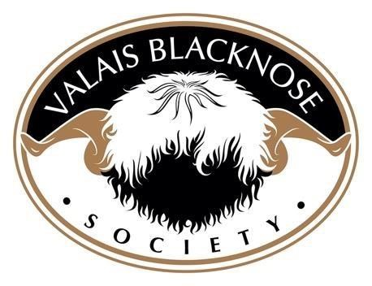
Ayr Show - Saturday 11th May 2024

CLASS | 1ST |  | 2ND | 3RD
AGED RAM | Kinneff Jacobsen  Owned by Tom Blackwood  Bred by Jo Jacobsen | Goldies Jockey ET  Owned by Morgan Dempsie  Bred by Bruce Goldie |  |  | Ayrshire Kraken  Owned and bred by  Tom Blackwood
RAM LAMB | Nithsdale Kain  Owned and Bred by Cat Losty | Ayrshire Lex Luther  Owned and bred by  Tom Blackwood |  |  | Spango Knickerbocker  Owned and bred by  Alistair Scott
AGED EWE | Goldies Jill ET  Owned by Morgan Dempsie  Bred by Bruce Goldie | Spango Japonica  Owned and Bred by  Alistair Scott
SHEARLING EWE | Whiterigg Koko Chanel  Owned and Bred by  Katrina And Robbie Taylor | Whiterigg Kick em Jenny  Owned and Bred by  Katrina And Robbie Taylor |  |  | Ayrshire Jasmine  Owned and bred by  Tom Blackwood
EWE LAMB | Nithsdale Katori  Owned and Bred by Cat Losty | Bridgehaugh Mill Lauder Lass  Owned by Katrina And Robbie Taylor  Bred by David Taylor |  |  | Nithsdale Kiva  Owned and Bred by Cat Losty
GROUP OF 3 | Whiterigg K2, Koko Chanel and Kick ‘em Jenny  Owned and Bred by  Katrina And Robbie Taylor | Nithsdale Kain, Katori and Kiva  Owned and Bred by Cat Losty | Kinneff Jacobsen, Ayrshire Jasmine and Lex Luther  Owned by Tom Blackwood  Bred by Jo Jacobsen

RESERVE CHAMPION CHAMPIONSHIPSHON |  |  |  | RESERVE CHAMPION | RESERVE CHAMPION
SUPREME CHAMPION | Whiterigg Koko Chanel  Owned and Bred by  Katrina And Robbie Taylor | RESERVE CHAMPION | Kinneff Jacobsen  Owned by Tom Blackwood  Bred by Jo Jacobsen

