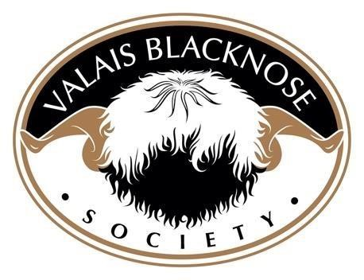
RUAS Balmoral Show – 16th May 2024
CLASS 1ST |  |  |  | 2ND | 3RD |  | 4TH | 5TH | 6TH
AGED RAM | Just likeDad.  Owned by Irene Gray & Hannah Morrison and bred by Irene & Geoffrey Gray |  |  | Elginny Junior ET  Owned and Bred  By Sharon McAllister |  | Diamond Invincable  Owned by Annmarie Oloughlin & Bred by Irene and Geoffrey Gray
SHEARLING RAM | Diamond Jackpot ET  Owned and Bred by Irene & Geoffrey Gray |  |  | Cavanalee Kendrick ET  Owned and Bred By Emma& Ryan Conway |  | Cavanalea Jaxon ET  Owned and bred by Emma &Ryan Conway | Diamond King ET  Owned and Bred by Irene & Geoffrey Gray | Elginny Kylian ET  Owned and bred by Sharon McAllister | Lettybrook Knox  Deirdre &Matthew  Morrow
RAM LAMB | Cavanalee King Kanute ET  Owned and bred by Emma &Ryan Conway |  |  | Lettybrook Kryptonite ET  Owned and bred by Deirdre & Matthew Morrow |  | Diamond President Kennedy ET  Owned and bred by Irene and Geofrey Gray | Lettybrook Kinetic ET  Owned and bred by Deirdre and Matthew Morrow | Lettybrook Laser ET  Owned and bred by Deirdre and Matthew Morrow | Cavanalee Kyro ET  Owned and bred by Emma & Ryan Conway
AGED EWE | Cavanalee Judy ET  Owned and bred by Emma & Ryan Conway |  |  | Beatties Irene ET  Owned by Irene & Geoffrey Gray bred by Richard Beattie |  | Slieveroe Jessie  Owned by Hannah & Gareth Morrison bred by Diane Lowry. | Highland Indi ET  Owned by Irene & Geoffrey Gray bred by Jenni McAllister & Raymond Irvine | Primrose Juliet  Owned and bred by Primrose Hill Family | Cavanalee Jenni  Owned by Aimee Liggett & bred by Emma & Ryan Conway
SHEARLING EWE | Claraghmorr Joy ET  Owned by Hannah & Gareth Morrison bred by Irene & Geoffrey Gray |  |  | Diamond Just Like Mama ET  Owned and bred by Irene & Geoffrey Gray |  | Lettybrook Julie ET  Owned and bred by Deirdre & Matthew Morrow | Cavanalee Jemina ET  Owned and bred by Emma & Ryan Conway | Cavanalee Karlie ET  Owned and bred by Emma & Ryann Conway | Causeway Kylah ET  Owned by AnnMarie O Loughlin bred by Veronica Higgins
EWE LAMB | Diamond Kurly Sue ET  Owned and bred by Irene & Geoffrey Gray |  |  | Cavanalee Kiki ET  Owned and bred by Emma & Ryan Conway |  | Diamond Kurly Wurly ET  Owned and bred by Irene & Geoffrey Gray | Lettybrook Kazoo ET  Owned and bred by  Deirdre & Matthew Morrow | Cavanalee Karma ET  Owned and bred by Emma & Ryan Conway | Lettybrook Lottie ET  Owned and bred by Deirdre & Matthew Morrow
CLASS | 1st1ST |  |  | 2ND |  | 3RD | 4TH | 5TH | 6TH
YOUNG HANDLER |  |  |  | Diamond Katherine  Owned by Mia Sloane and bred by Irene & Geoffrey Gray
PAIRS |  |  |  |  |  |  |  |  | Claraghmorr Joy &  Cavanlee Jenna  Owned by Hannah & Gareth Morrison

RESERVE CHAMPION | RESERVE CHAMPION | RESERVE CHAMPION | RESERVE CHAMPIONSHIP | RESERVE CHAMPION | RESERVE CHAMPION | RESERVE CHAMPION
SUPREME CHAMPION | Claraghmorr Joy (ET) Owned by Hannah & Gareth Morrison bred by Irene and Geoffrey Gray |  | RESERVE CHAMPION | Cavanalee King Kanute (ET)  Owned and bred by Emma & Ryan Conway

