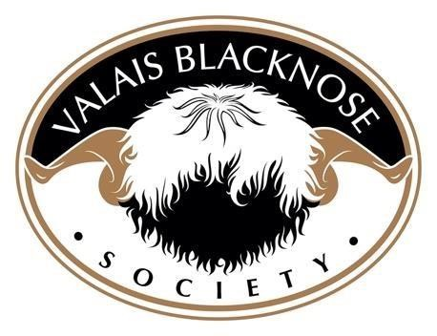
Royal Bath & West 30th May 2024
CLASS 1ST |  | 1st |  | 2ND | 3RD |  | 4TH | 5TH | 6TH
AGED RAM | Lacock Jethro ET  Owned and bred by Peter Self |  |  | Gemstones Ivan  Owned and bred by Emma Collison
SHEARLING  RAM | Lacock Kingston ET  Owned and bred by Peter Self |  |  | Lambrook Kermit  Owned and bred by Carla Bunter |  | Gemstones Kennedy  Owned and bred by Emma Collison
RAM LAMB | Gemstones Lord Lancelot  Owned and bred by Emma Collison |  |  | Lambrook Lando  Owned and bred by Carla Bunter |  | Combeshead Leonardo  Owned and bred by Vicki Evans | Venn Valley Louis Owned and bred by  Lesley Marshall
AGED EWE | NewHouse Isla ET  Owned by Nina Price Bred by A D Evans & Co |  |  | Brendon Hill Poppy  Owned and bred by Laura Giles |  | Gemstones Inola  Owned and bred by Emma Collison | Halesbury Jackson ET  Owned by Vicki Evans and bred by  Chris Slee & Tom Hooper
SHEARLING EWE | Lacock Kalinda  Owned and bred by Peter Self |  |  | Gemstones Kelia Marie  Owned and bred by Emma Collison |  | Fairview Valleys Jubilee ET  Owned and bred by Nina Price | Lambrook Kitty  Owned and bred by Carla Bunter | Venn valleys Jubilee  Owned and bred by Lesley Marshall | Horsemill Junelle  Owned by Jessica Hill  & Bred by Anne Garthwaite & Claire McGeorge
EWE LAMB | Brendon Hill Lindy  Owned and bred by Kathy Giles |  |  | Brendon Hill Lily  Owned and bred by Kathy Giles |  | Lambrook Lillibet  Owned and bred by Carla Bunter | Lambrook Lupin  Owned and bred by Carla Bunter
PAIR OF SHEEP | Lacock Flock  Owned and bred by Peter Self |  |  | Lambrook Flock  Owned and bred by  Carla Bunter |  | Harelaw  Owned by Jessica Hill & bred by Anne Garthwaite & Claire McGeorge
GROUP OF THREE | Venn Valleys  Owned and bred by Lesley Marshall |  |  | Brendon Hill Flock  Owned and bred by Kath Giles |  | Gemstones Flock  Owned and bred by Emma Collision | Harelaw Flock  Owned by Jessica Hill

CHAMPIONSHIPS

LONGWOOL OR UPLAND WOOL ON THE HOOF CHAMPION | Exmoor Larry  Owned and bred by Laura Giles
INTERBREED WOOL ON THE HOOF CHAMPION | Exmoor Larry  Owned and bred by Laura Giles
MALE CHAMPION | Gemstones Lord Lancelot  Owned and bred by Emma Collison | RESERVE MALE CHAMPION | Lacock Jethro ET  Owned and bred by Peter Self
FEMALE CHAMPION | NewHouse Isla ET  Owned by Nina Price Bred by A D Evans & Co | RESERVE  FEMALE CHAMPION | Lacock Kalinda  Owned and bred by Peter Self
SUPREME CHAMPION | Gemstones Lord Lancelot  Owned and bred by Emma Collison | RESERVE CHAMPION | Lacock Jethro ET  Owned and bred by Peter Self

