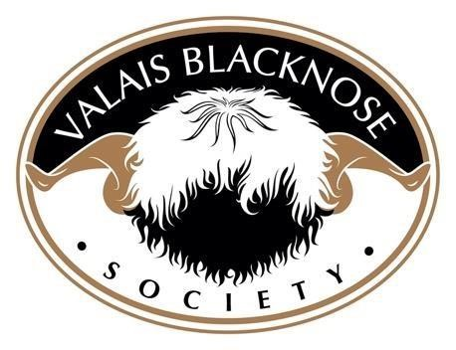
Drymen Show 25th May 2024
CLASS 1ST |  | 1st |  | 2ND | 3RD
RAM | Highland Jammy ET  Owned and bred by Raymond Irvine & Jenni McAllister |  |  | Glenchamber Jaffa  Owned by Alistair Scott & Craig Scott  Bred by Zoe McLillian | Whiterigg K2  Owned and bred by Robbie & Katrina Taylor
RAM LAMB | Highland Kili  Owned and bred by Raymond Irvine & Jenni McAllister |  |  | Nithsdale Kain  Owned and bred by Cat Losty | Spango Knickerbocker  Owned and bred by Alistair Scott & Craig Scott
AGED EWE | Hardens Jasmine  Owned and bred by Rikki & Lauren Mclean |  |  | Hardens Jessica  Owned and bred by Rikki & Lauren Mclean | Whiterigg Jingle Jangle  Owned and bred by Robbie & Katrina Taylor
SHEARLING EWE | Whiterigg Koko Chanel  Owned and bred by Robbie and Katrina Taylor |  |  | Highland Kit-Kat  Owned and bred by Raymond Irvine & Jenni McAllister | Pendock Krumpet  Owned by Robbie & Katrina Taylor  Bred by Emma Humphreys
EWE LAMB | Nithsdale Katori  Owned and bred by Cat Losty |  |  | Bridgehaugh Mill Lauder Lass  Owned by Robbie & Katrina Taylor  Bred by David Taylor | Nithsdale Kiva  Owned and bred by Cat Losty
GROUP OF THREE | Whiterigg flock  Koko Chanel, Kick em ’Jenny & K2  Owned and bred by Robbie & Katrina Taylor |  |  | Nithsdale Flock  Katari, Kiva and Kain  Owned and bred by Cat Losty | Hardens Flock  Jasmin, Jessica and Ironman  Owned and bred by Rikki & Lauren Mclean

RESERVE CHAMPION | RESERVE CHAMPION | RESERVE CHAMPION | RESERVE CHAMPION | RESERVE CHAMPION | RESERVE CHAMPION | RESERVE CHAMPION
SUPREME CHAMPION | Highland Kili  Owned and bred by Raymand Irvine & Jenni McAllister |  | RESERVE CHAMPION | Whiterigg Koko Chanel  Owned and bred by Robbie & Katrina Taylor

