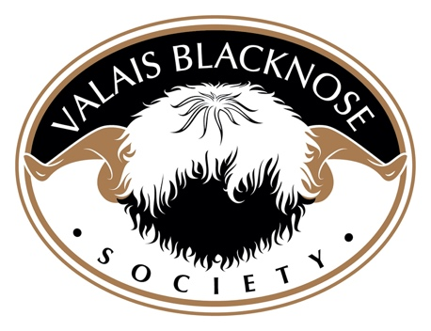

Dear Valais Blacknose Society Member,

We write to inform you that the application to register all ET lambs born before end April 2024 MUST be received by the end of May 2024, and will be charged at the current rate of £60 inc VAT to include DNA parentage testing.
Any ET lambs born after 1st May 2024, and ALL ET registry application received after 30th May 2024 regardless of when the lamb was born, will be charged at the new rate of £250 inc VAT, to include DNA parentage testing.
Please note, the ET paperwork for the collection and implantation of ET lambs should be sent to Grassroots as soon after implantation as possible and before the lambs are born. All ET donor females and service sires MUST be DNA profiled.
We would also like to inform you that ET lambs may be NOTIFIED, but only the breeder can register a lamb. ET lambs must not be sold until they have been DNA parentage verified and fully registered.
If you have any questions relating to the above matter, please email - secretary@valaisblacknosesociety.co.uk
Raymond Irvine
Chair; on behalf of the VBN Society Council

